Technical Report: Movie Recommendation Analysis

1. Data Loading
Loads 'movies.csv' into a Pandas DataFrame with 4803 rows and 24 columns, including budget, genres, overview, vote average, cast, crew, and director. Sample shows top blockbusters: Avatar (budget $237M, genres Action/Adventure/Fantasy/Sci-Fi, rating 7.2), Pirates of the Caribbean sequels, and more.
Tools & Technologies
- Python
- Pandas, NumPy
- Scikit-learn
- Cosine Similarity
Dataset information
- Movie titles
- Genres
- Ratings

2. Data Cleaning
Duplicates are removed using movies_data.drop_duplicates(), ensuring unique entries.
Selected features for recommendation—genres, keywords, tagline, cast, director—are identified and null values are filled with empty strings via a loop: for feature in selected_features: movies_data[feature] = movies_data[feature].fillna('').
- Remove duplicates
- Handle missing values
This prepares textual data without loss, avoiding imputation biases in content-based systems.​

3. Feature Engineering
The five features are concatenated into a single 'combined_features' column: movies_data['genres'] + movies_data['keywords'] + ... + movies_data['director'].
Text is vectorized using TfidfVectorizer(), producing feature_vectors as a sparse matrix of shape (4803, 17318) with 124,266 non-zero elements.
- Convert text data (genres, tags) into vectors
This TF-IDF transformation captures term importance across movie descriptions for similarity computation.​

4. Model Building
A content-based filtering approach uses cosine_similarity on the TF-IDF feature vectors, generating a similarity matrix of shape (4803, 4803). Diagonal elements are 1.0 (self-similarity), with off-diagonals like 0.072 for Avatar-Pirates of the Caribbean indicating moderate matches.
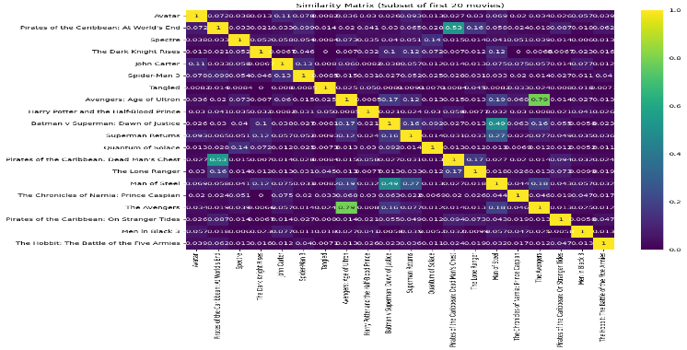
This matrix enables efficient retrieval of top similar movies without collaborative filtering or user ratings.​

5. Recommendation Logic
User inputs a favorite movie name, e.g., "Guardians of the Galaxy", matched closely to the dataset's title list via difflib (4803 titles).
The input's index retrieves its similarity row; indices of top 5 non-self matches (sorted descending) are fetched.
Titles are pulled from movies_data['title'] for output, prioritizing highest cosine scores.​

6. Output
Recommendations display as top similar movies, e.g., for "Guardians of the Galaxy":
- Avatar
- The Chronicles of Riddick
- Star Trek Beyond
- Star Trek Into Darkness
- Moonraker
The top 5 recommendation movie
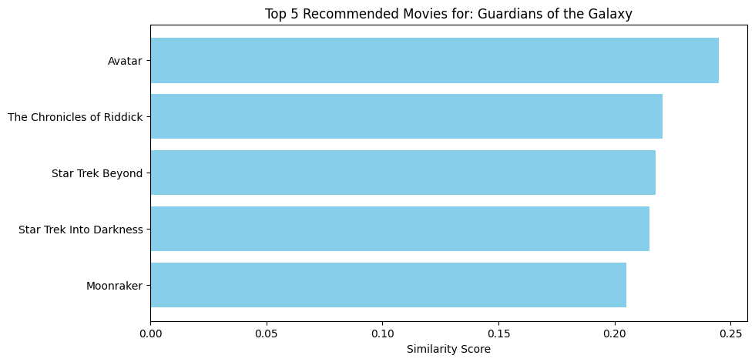

(Up to top 30, excluding input). This interactive demo runs in a loop for multiple queries

